ARE ALL YOUNG PEOPLE VIOLENT?

Тема: Are all young people violent?
Задачи: Практиковать учащихся в чтении с извлечением конкретной информации. Ознакомить с группировками существующими в России. Научить составлять предложения по схемам. Заполнить таблицу( True or False)
Цели: Выявить знание лексических единиц.
Ознакомить с жизнью молодёжи в стране и за рубежом.
Оборудование: таблицы, карточки со словами и предложениями,
картинки, диск к учебнику Кузовлева В.П.

Ход урока
- Организационный момент
Who is on duty today?
What date is it today?
What day is it today?
What is the weather like today?
What about new?
- Объяснение урока
Children we talk about young people.
Let’s repeat some words.
Look at table and read words.
- Make sentences

I think  I agree  To my mind | teens  people  they  grown-ups  subcultures  parents | protest  want  support  saying  reject  don’t live  don’t think | In desert  against parents  to show off  youth clubs  no  everything  peace  against society  to change  the world  about future

- Make sentences
Bikers  Skinheads  Punks  Goths  Rockers  Hackers | Scare  Kill  Dye  Wear  Listen | Passers-by  People  Hair brightly color  The blackest clothes  A cowboy hat  Techno industrial music

- Make the table (Write subcultures
Speaker | 1 | 2 | 3 | 4 | 5 | 6 | 7 | 8 | 9 | 10
Statement

Now children we listen music,
Today young people listen
Different styles of music.
- Children open your books on page 88 and listen (A,B,C).
Write true or false.
- Young people out on the street late at night.
- Teens help school and society.
- Subcultures are like gangs.
- Young people are potential criminals.
- Society care about teens.
- There are not enough sports clubs .
- Teens can’t afford clubs because clubs are expensive.
- Teens don’t think about future.
- A lot of teens think about changing the world for best.
- Society can not suggest anything really.

- Read cards (Раздаются карточки с микротекстами)
Name subculture.
Pass your projects, please
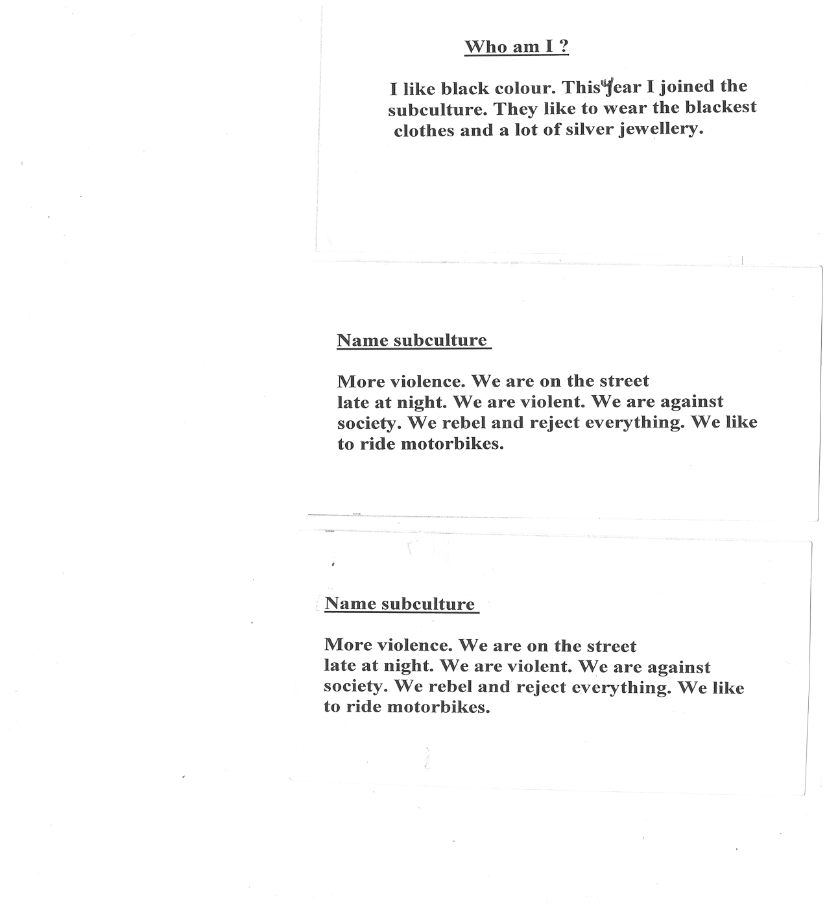

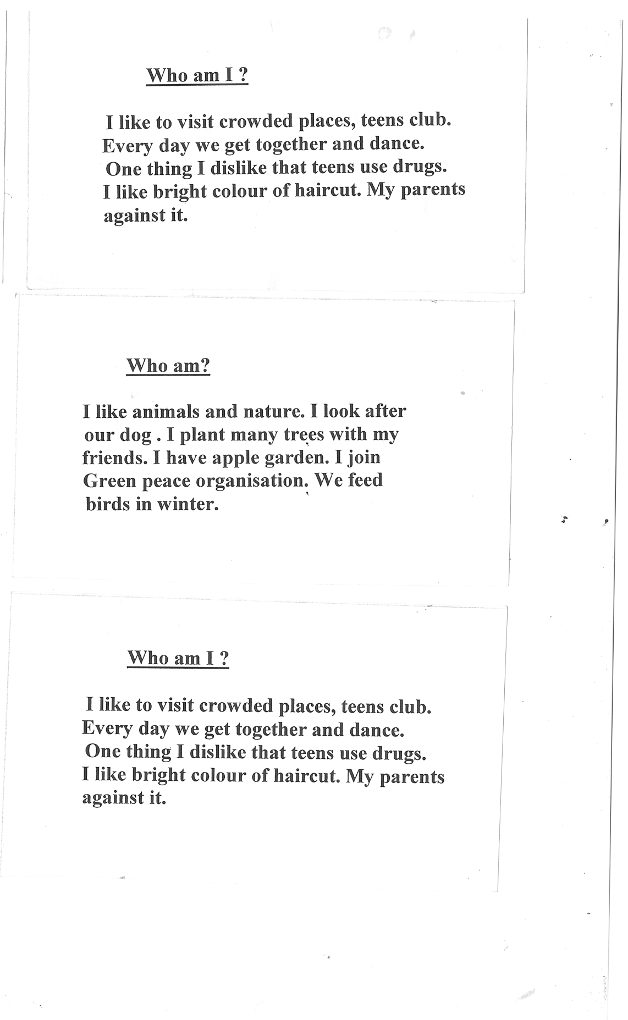

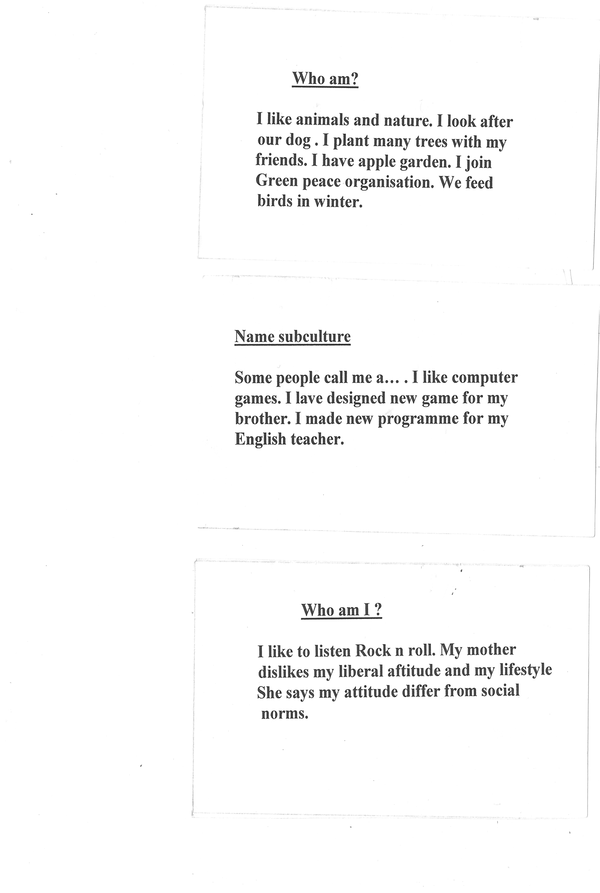

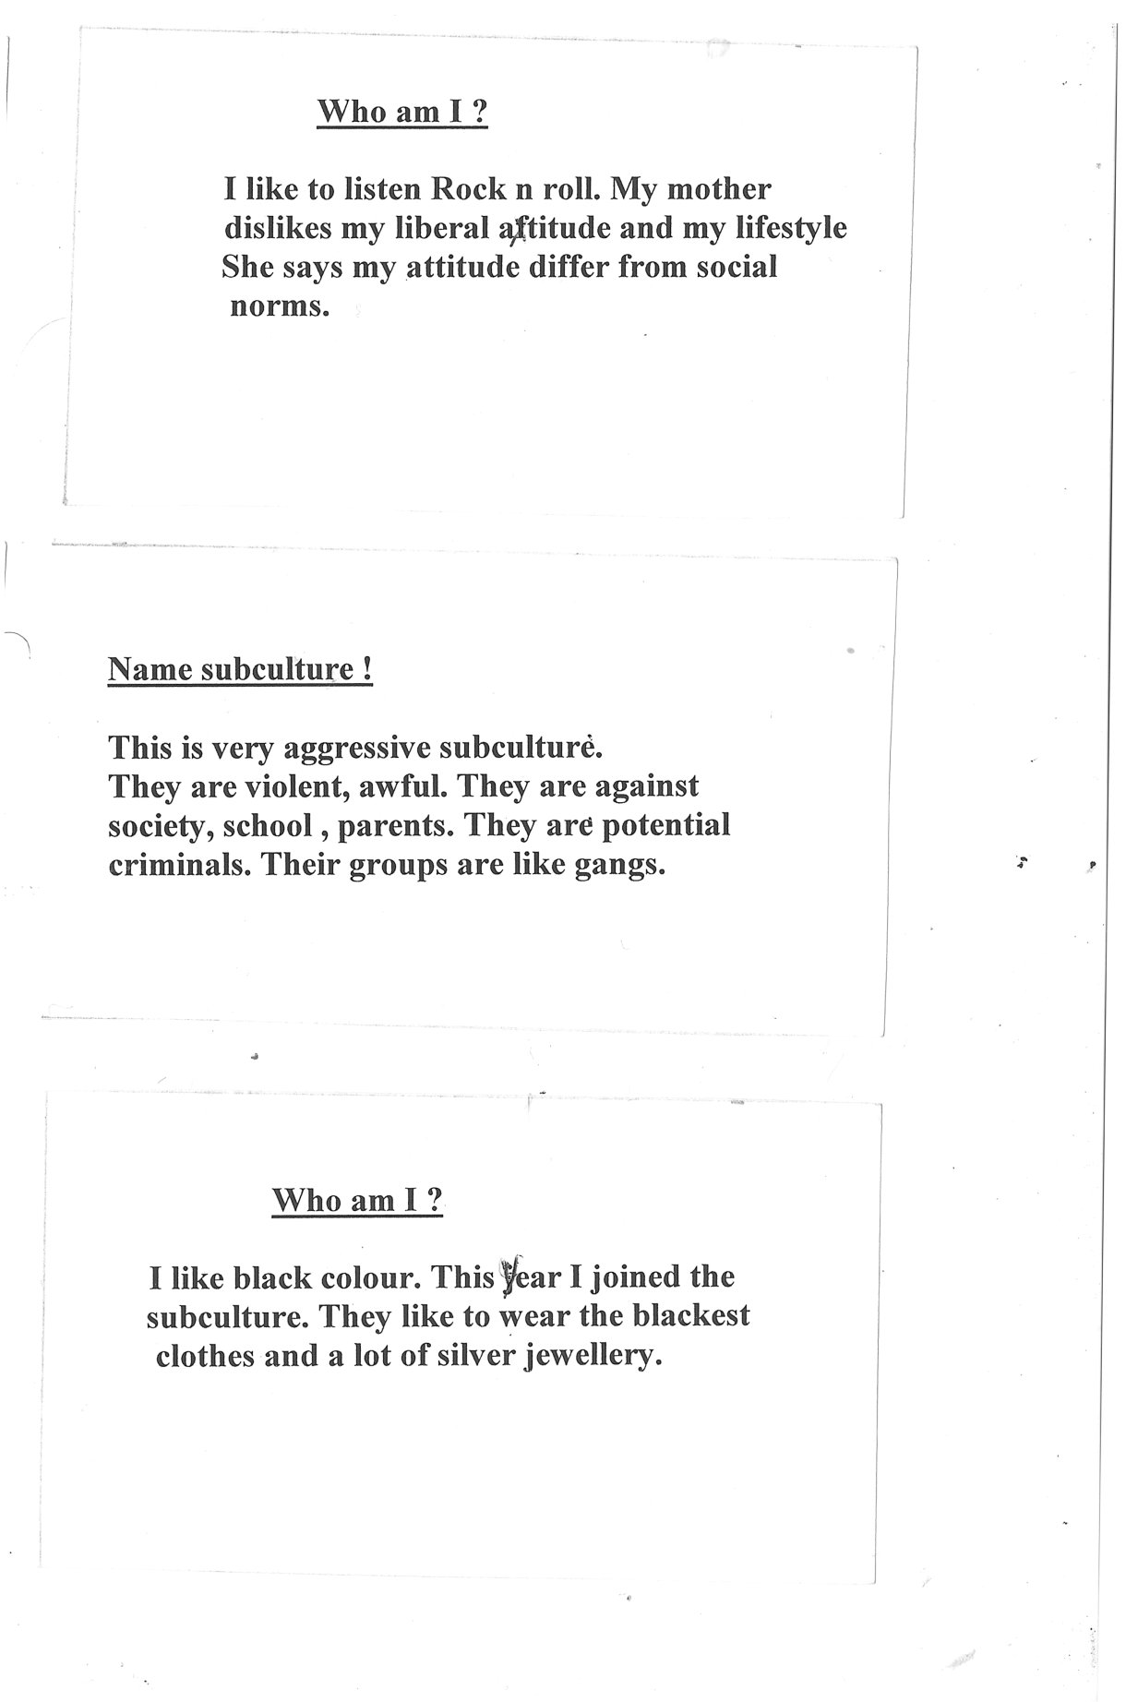

- Our lesson is over.
I was glad to meet with you.
Luck, best wishes to you.
Good bye!

Приложение 1
Приложение 2

